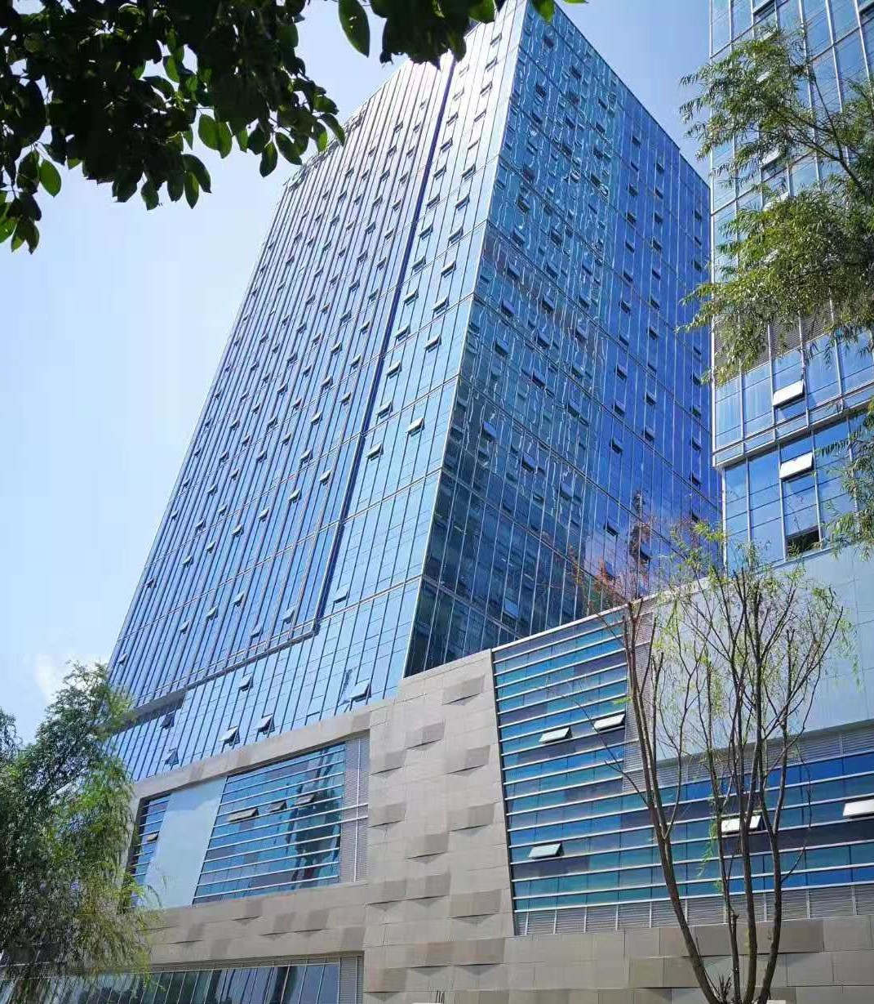

Encapsulated Calcium Sulphate Raised Floor

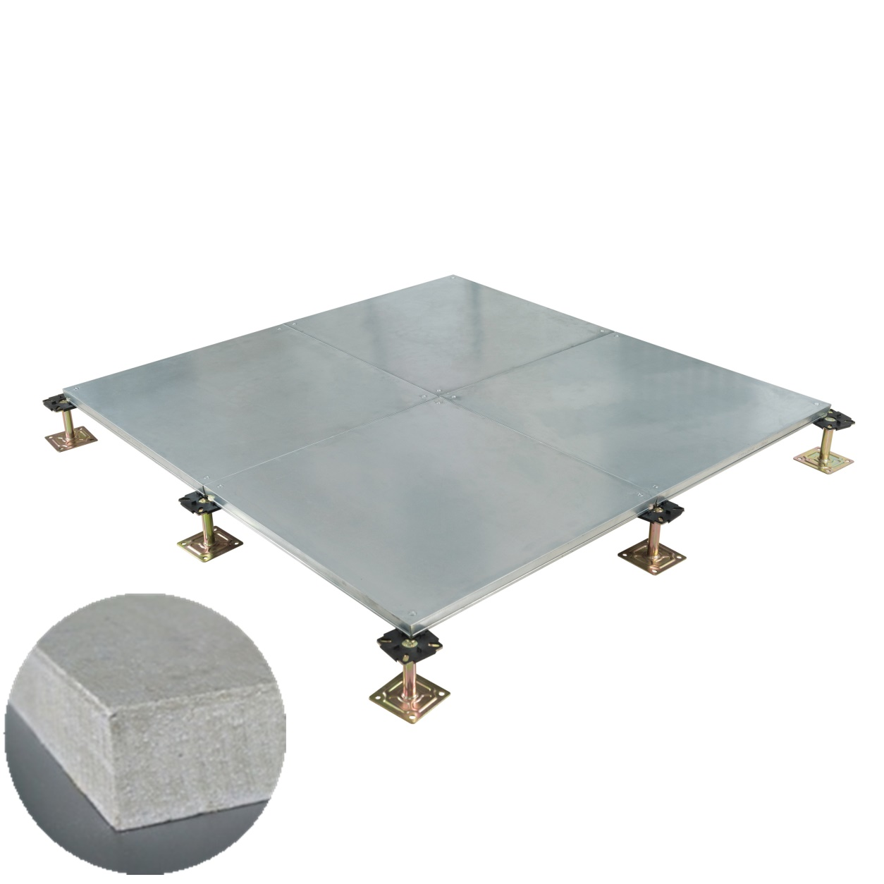

Abeite Encapsulated Calcium Sulphate Raised Floor is made by 100% green
environmental protection natural gypsum powder. From the selection of materials,
procurement, production, packaging, are compliant with the Chinese and PSA MOB
PS/SPU、DIN EN 12825 specifications.

Construction:
Encapsulated Calcium Sulphate Raised Floor is based on a high-density calcium
Panel, then encapsulated by A grade Galvanized Steel from six sides of the panel.

Finished Floor Height: | 100-1000mm
Panel Size: | 600*600*26mm、600*600*30mm
Corner Lock Hole | With or without
Installation: | Corner lock / Bolted stringer

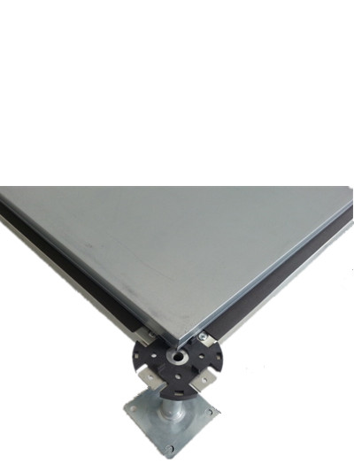

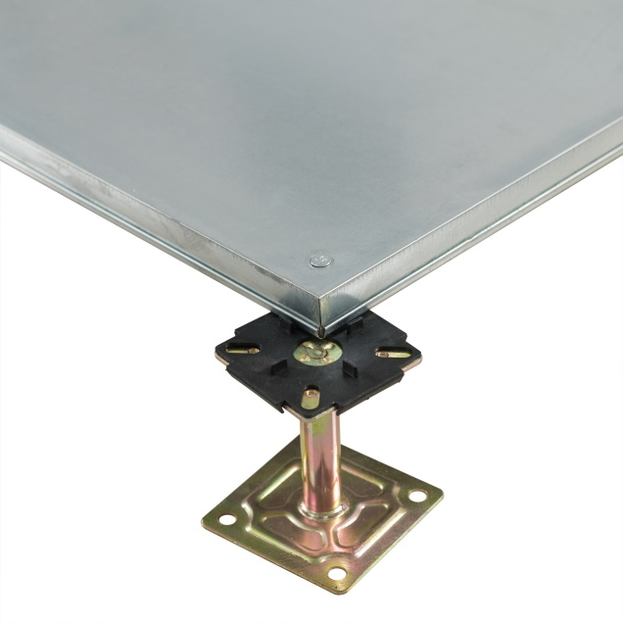

Corner lock Bolted stringer

Characteristics:
1、All-inclusive closed structure, strong sealing;
2、Tolerance of panel size is 0-0.40mm; Tolerance of panel thickness is ±0.30mm;
Un-flatness is ≤0.60mm;
3、The load performance is strong and high impact resistance.
4、Good performance in flame retardant, heat insulation, sound insulation, and
corrosion protection;
5、The appearance is neat and beautiful, the decoration is strong, and the walking
foot is comfortable.

Applications:
Data Centers、Commercial Buildings、Educational Facilities、Clean Rooms、
Control Rooms、Libraries and places where require anti-static environment or
have many wires.

Size | Concertrated Load |  |  | Uniform Load | Ultimate Load | Fire Rate
mm | LBS | KN | KG | KN/㎡ | KN
600*600*26mm | 662 | 2.95 | 300 | 12.50 | 8.85 | Incombustible  ASTM E84-01:  Flame Spread:0  Smoke Density:0
600*600*30mm | 800 | 3.56 | 363 | 16.10 | 10.68

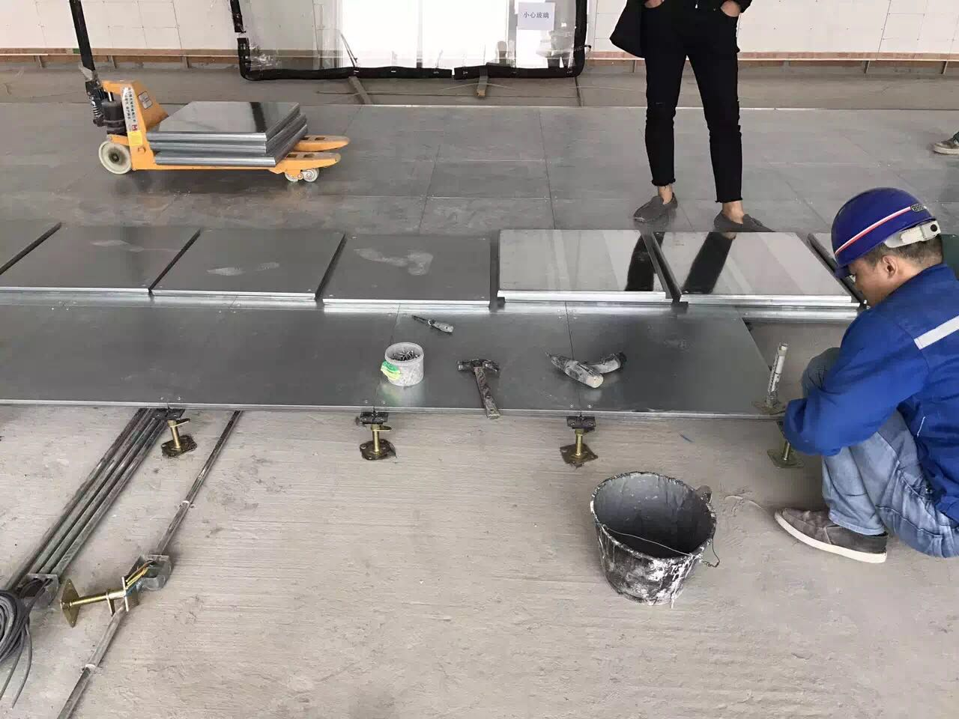

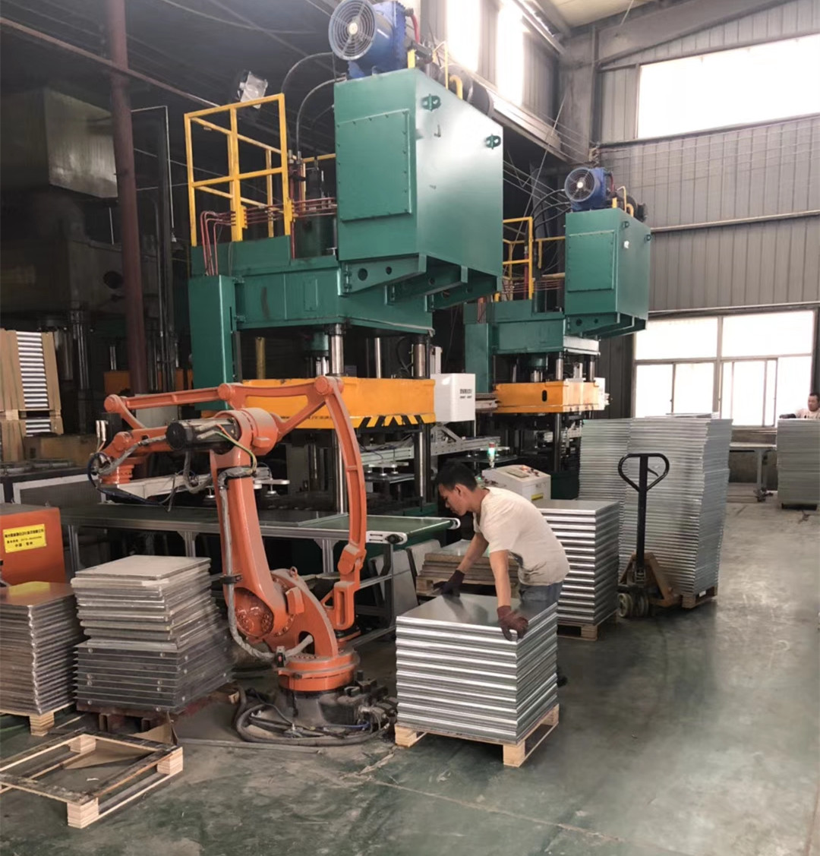

Changzhou Abeite Computer Room Equipment Co.,Ltd
Add: No. 108, Chaoyang Village, Hengshanqiao Town, Wujin District,
Changzhou City, Jiangsu Province，China
Tel: +86(519)86056270
Fax: +86(519)86056270
E-mail: info@abeiteraisedfloor.com
Web: www. abeiteraisedfloor.com

