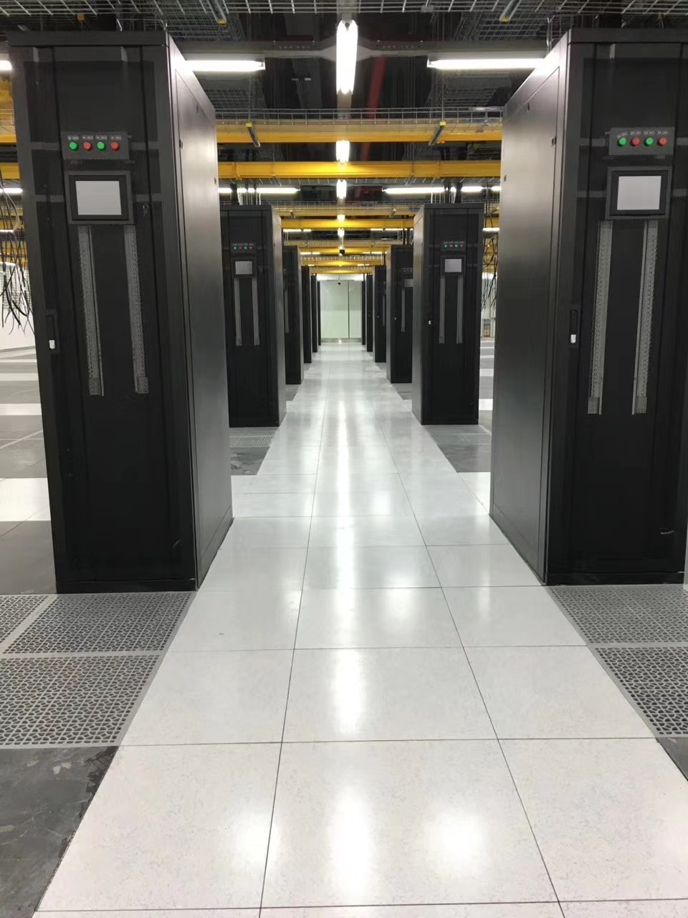

Calcium Sulphate Raised Floor
Фальшпол из сульфата-кальция

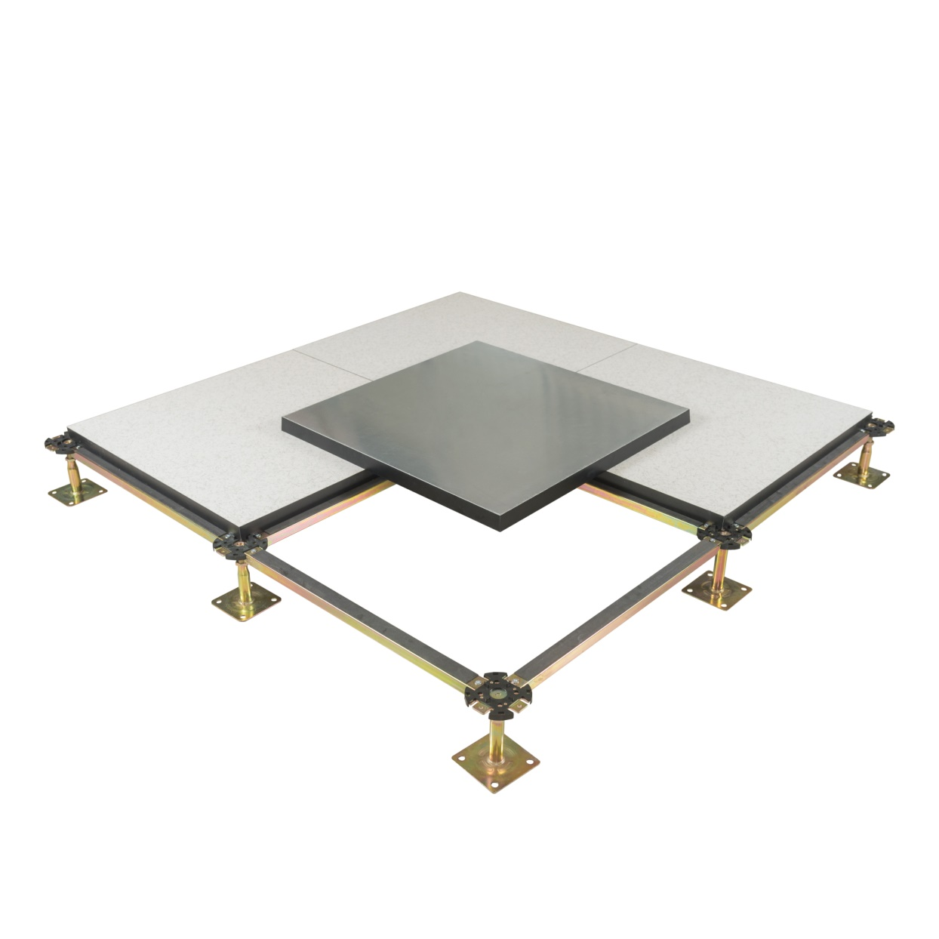
Abeite Calcium Sulphate Raised Floor is hot selling product, it’s made by 100% green environmental protection natural gypsum powder. From the selection of materials, procurement, production, packaging, are following the Chinese and PSA MOB PS/SPU、DIN EN 12825 specifications. With the German brands Mero and Lindner as the goal, to provide our customers with high-quality products.

Construction:
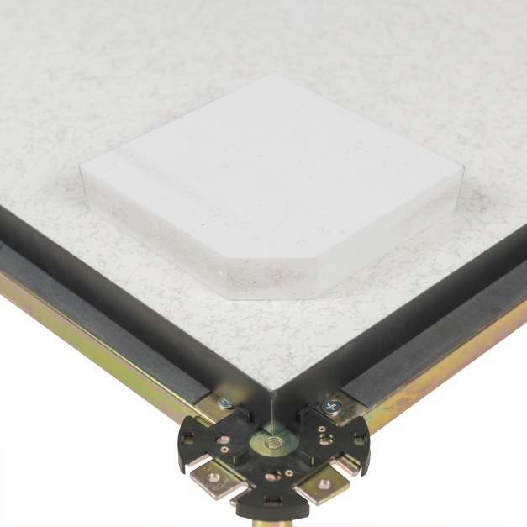
Calcium Sulphate Raised Floor is based on a high-density calcium panel, finished with HPL/PVC/Ceramic and other covering, galvanized steel sheet or aluminum foil to bottom, the four edges are wrapped with conductive PVC trims.
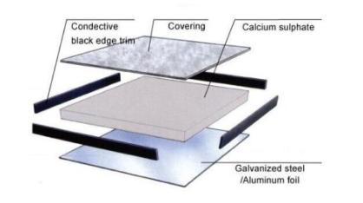

Finished Floor Height: | 100-2000mm
Density: | 1500-1700 kg/m³
Panel Size: | 500*500mm、600*600mm and special size
Core Panel Thickness: | 22-38mm
Upper Covering: | Bare、1.0-2.0mm Anti-static Laminate HPL、2.0-3.0mm PVC、10mm Cermic、Marble、Granite、Nature Wood、and etc.
Under Covering: | Bare、0.3-2.0mm Galvanized steel、0.1-2.0mm Aluminum Foil
Installation: | Without or With Stringer System
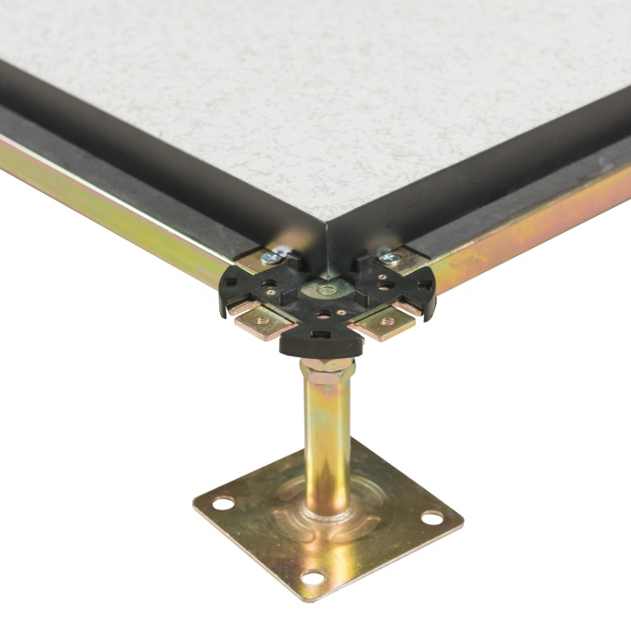
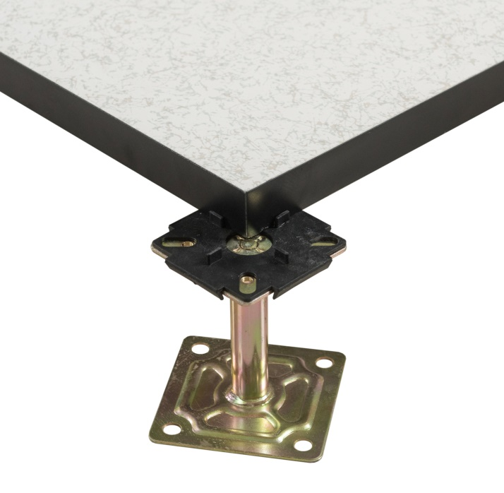

With Stringer System Without Stringer System

Characteristics:
- Non-toxic natural product, 100% green environmental protection natural gypsum power;
- 90% recycled can meet the requirement of LEED evaluation for projects;
- Tolerance of panel size is 0-0.40mm; Tolerance of panel thickness is ±0.30mm; Un-flatness is ≤0.60mm;

- The load performance is strong, and the anti-static performance is excellent.
- Good performance to Moisture resistance、Anti-corrosion、Class A1 Fire resistance(baseboard);
- OEM and customization are available;

Applications:
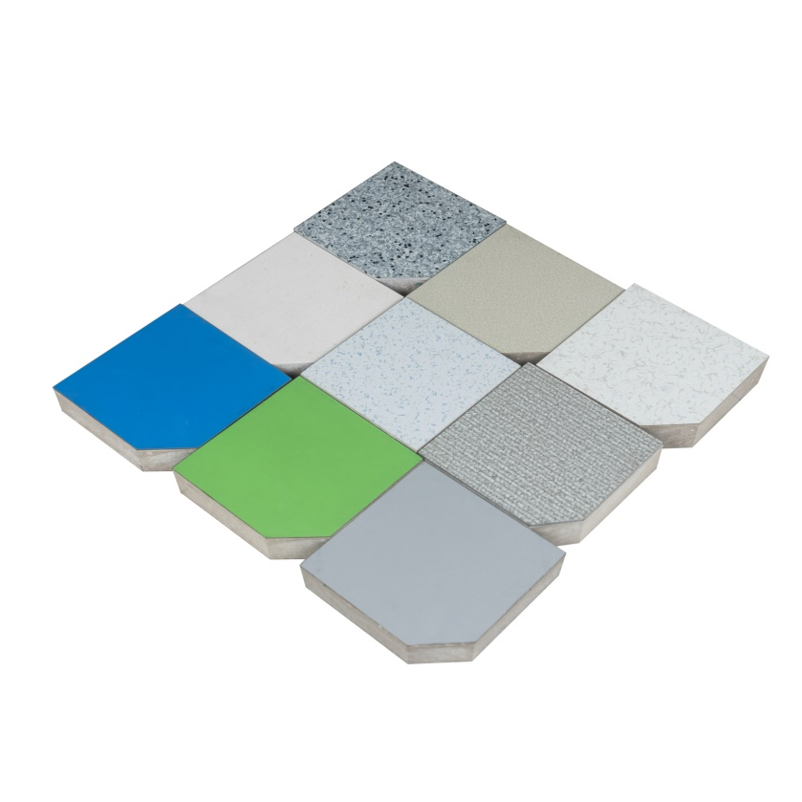
Calcium Sulphate Raised Floor is widely in Data Centers、Commercial Buildings、Educational Facilities、Clean Rooms、Control Rooms、Libraries and places where require anti-static environment or have many wires.
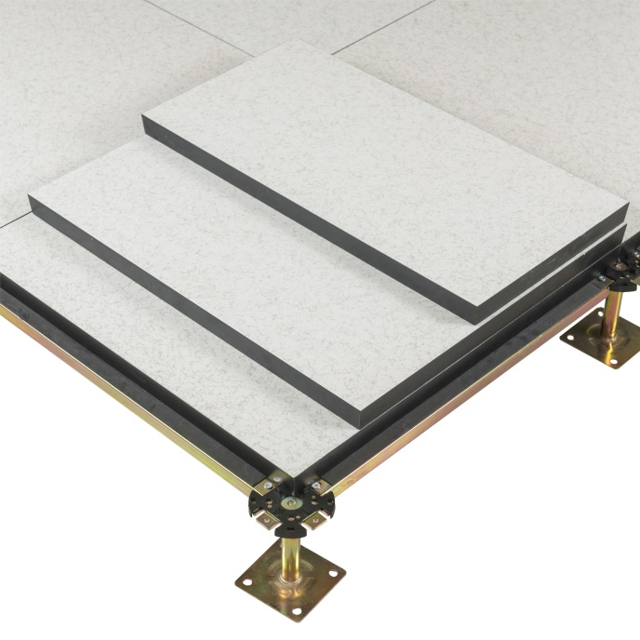

Special size panel Customized covering

Specification:

Type | Load Level | Size | Concertrated Load Defleation≤2.5mm |  | Uniform Load | Ultimate Load | System Resistance
 |  | mm | LBS | KN | KN/㎡ | KN | Ω
FS800 | Medium Grade | 600*600 (500*500 is optional) | 800 | 3.56 | 16 | 10.68 | 1.0x10⁶-1.0x10⁹
FS1000 | Heavy Grade |  | 1000 | 4.45 | 23 | 13.35
FS1250 | Extra Heavy Grade |  | 1250 | 5.56 | 33 | 16.68
FS1500 | Industrial Grade |  | 1500 | 6.67 | 43 | 20.02
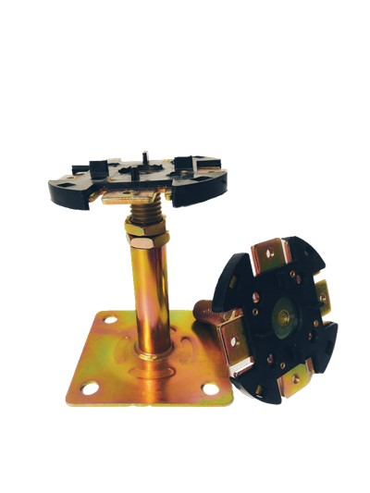

Understructures:
Product Name: | Round Head Pedestal
Suggested Height: | FFH100-600mm
Tube: | Φ21/1.5mm
Top Plate: | 90*90*3.0mm
Base Plate:: | 95*95*2.0mm
Threaded Rod: | M18/20/22
Threaded Rod Length: | 80mm/100mm and more
Surface: | Cold galvanizing Hot galvanizing Powder coated
Gasket: | With

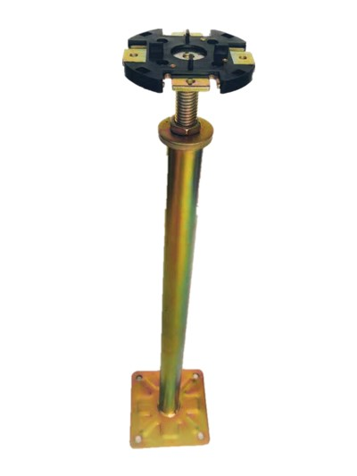
Product Name: | Heavy-duty pedestal
Suggested Height: | FFH600-2000mm
Tube: | Φ32/1.5mm
Top Plate: | 90*90*3.0mm
Base Plate:: | 95*95*3.0mm
Threaded Rod: | M18
Threaded Rod Length: | 80mm/100mm and more
Surface: | Cold galvanizing Hot galvanizing Powder coated
Gasket: | With
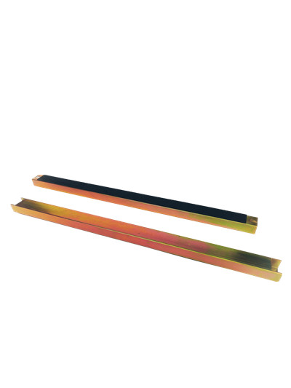

Product Name: | Stringer
Size: | 540*31*22mm  1140*31*22mm
Steel thickness: | 1.0/1.2mm
Surface: | Cold galvanizing Hot galvanizing Powder coated
Gasket: | With

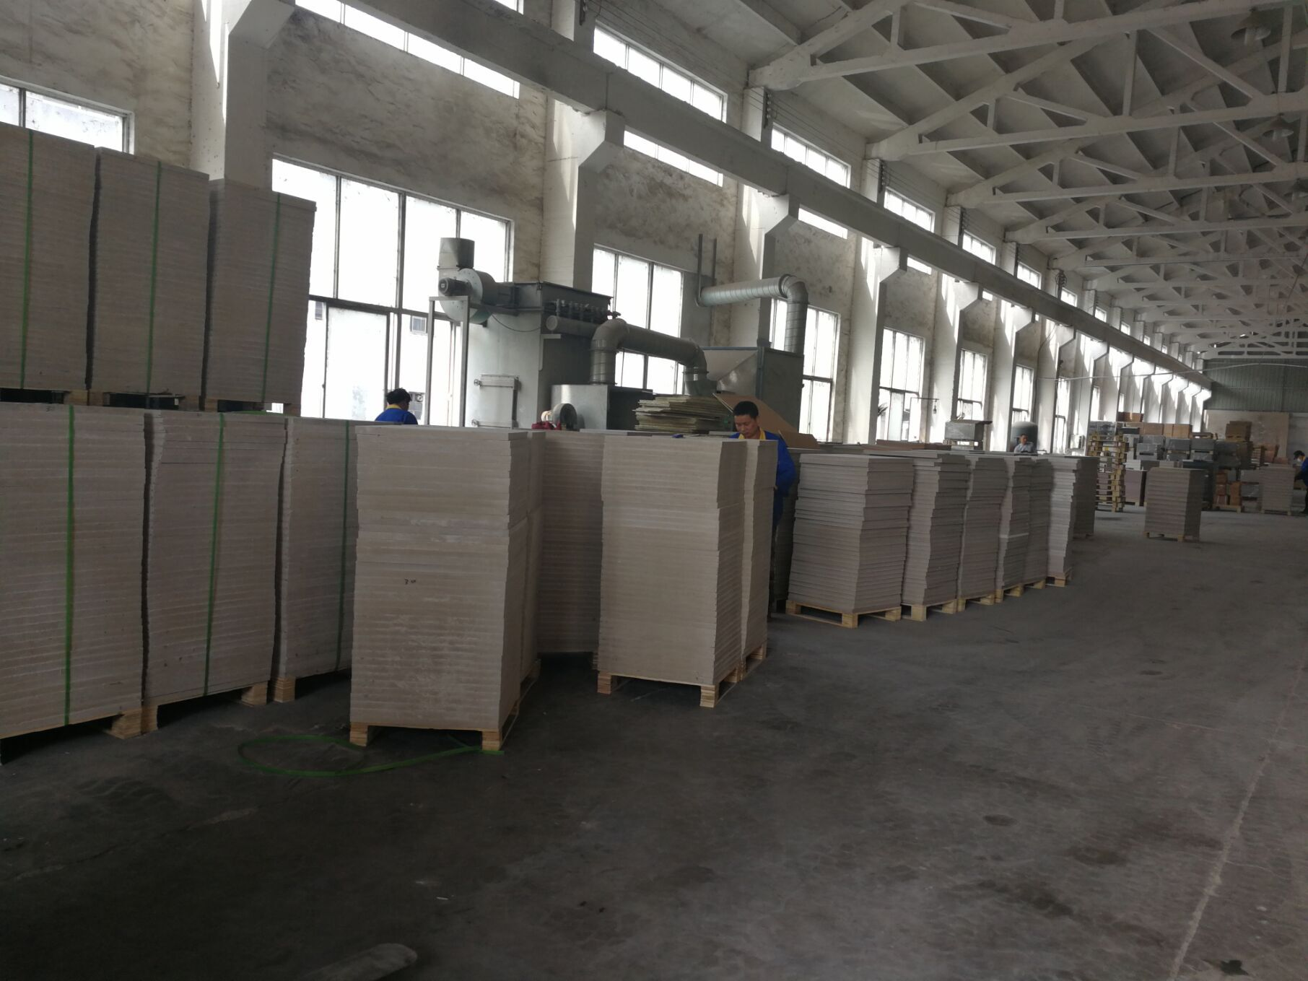

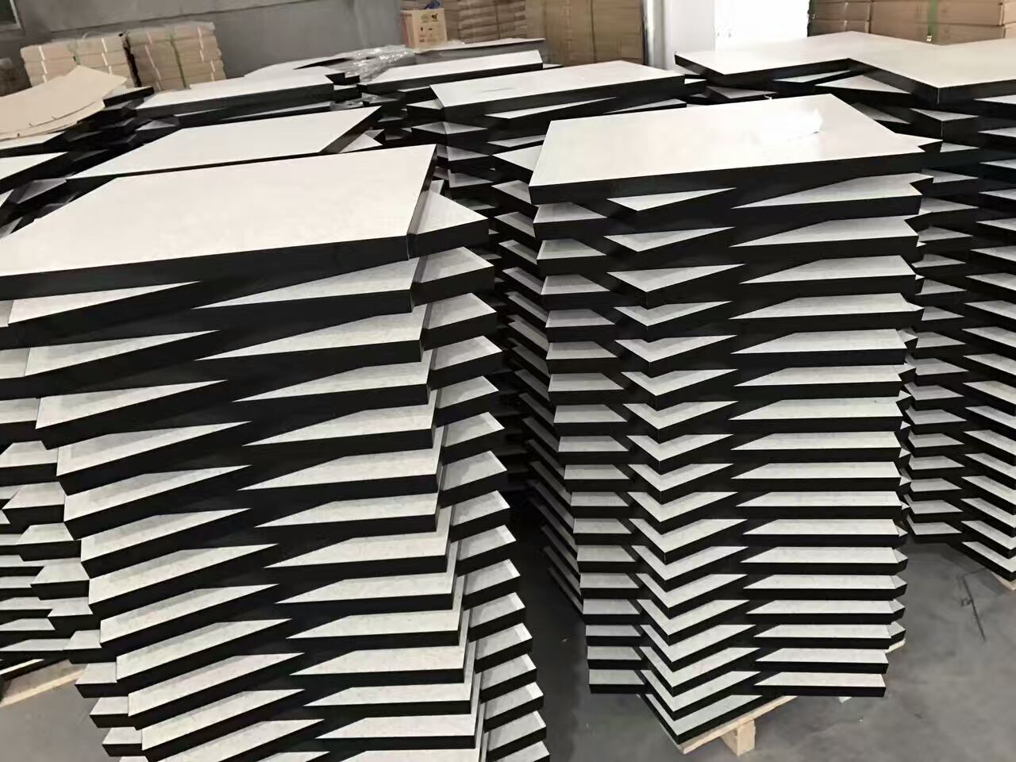

Changzhou Abeite Computer Room Equipment Co.,Ltd
Add: No. 108, Chaoyang Village, Hengshanqiao Town, Wujin District,
Changzhou City, Jiangsu Province，China
Tel: +86(519)86056270
Fax: +86(519)86056270
E-mail: gail@abeiteraisedfloor.com
Web: www. abeiteraisedfloor.com

